Assignment

1. Normalize this table

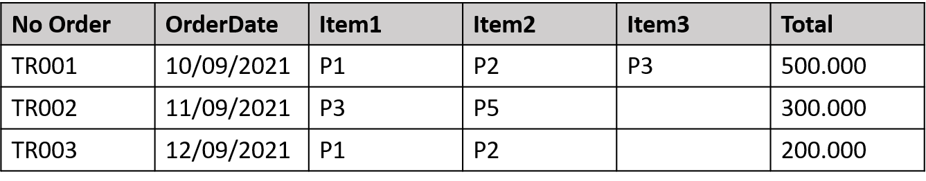

I need to determine the current location of this table and navigate through each normalization form, starting with the 1st Normal Form, until I find the appropriate form for this table.

a. 1st Normal Form (1NF)

For a table to be in 1NF, it must contain single values in every cell (not a set of values). Fortunately, this table already meets the 1NF criteria.

b. 2nd Normal Form (2NF)

A table in 2NF must meet the criteria of 1NF and ensure that every non-key attribute is fully dependent on the primary key. Let's examine the attributes here:

1) OrderDate → No Order

It is possible that OrderDate could be part of a composite key, but there is no clear description of the primary key attributes.

2) {item1, item2, item3} → price

It's evident that the sets of items collectively determine the price, indicating that the price value depends on the value sets. However, the value of the sets themselves still relies on the potential primary keys, which are No Order and OrderDate. Therefore, the table still complies with 2NF rules.

c. 3rd Normal Form (3NF)

To attain 3NF, a table must meet the criteria of 2NF and have no transitive dependencies, meaning that an attribute should not depend on another non-key attribute. In this case, all the attributes are dependent solely on the primary key, satisfying the 3NF requirements.

In conclusion, the table, after undergoing normalization, adheres to the rules of 3NF.

**2. Is this table normal? If yes, which normal form? Can we normalize it to a higher level normalization?**

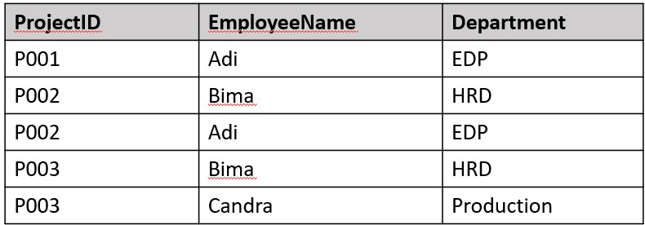

I've detected redundancy in the values of all the records within the table. To better understand the current state of the table, I'll delve into a more detailed analysis.

a. 1st Normal Form (1NF):

I have confirmed that the table meets the requirements of 1NF, as each cell or record in the table contains individual values.

b. 2nd Normal Form (2NF):

The table doesn't satisfy the 2NF criteria, and here's why:

1) There is no identified candidate or primary key for the table, as every column in the table lacks unique values.

2) Partial dependencies exist across the table. For example, EmployeeName depends on both ProjectID and Department, and Department depends solely on ProjectID. It could meet the 2NF standard if we assume that ProjectID is the primary key.

c. 3rd Normal Form (3NF):

The table doesn't exhibit transitive dependencies, which means it complies with the 3NF requirements.

To enhance the table's normalization, we can segregate or decompose it into two distinct parts, as illustrated below:

|  |  |
| --- | --- |
| ProjectID | EmployeeName |
| **P001** | Adi |
| **P002** | Bima |
| **P002** | Adi |
| **P003** | Bima |
| **P003** | Candra |

|  |  |
| --- | --- |
| ProjectID | Department |
| **P001** | EDP |
| **P002** | HRD |
| **P002** | EDP |
| **P003** | HRD |
| **P003** | Production |

With this separation, it's even possible to achieve BCNF (Boyce-Codd Normal Form) after eliminating redundancy.

**3. Is it normal form? If not, how to normalize it?**

|  |  |  |  |  |
| --- | --- | --- | --- | --- |
| **NRP** | **Name** | **Subject** | **NIP** | **Lecturer** |
| 5103100101 | Ali | SBD | 32151250 | Bapak X |
| 5103100102 | Sita | SBD | 32151250 | Bapak X |
| 5103100102 | Sita | Alin | 23000712 | Ibu Y |
| 5103100103 | Adi | Komnum | 43101253 | Bapak Z |

I can enhance the normalization by dividing it into two distinct tables: one for "Name" and another for "Lecturer."

|  |  |
| --- | --- |
| **NRP** | **Name** |
| 5103100101 | Ali |
| 5103100102 | Sita |
| 103100102 | Sita |
| 5103100103 | Adi |

|  |  |  |
| --- | --- | --- |
| **NIP** | **Subject** | **Lecturer** |
| 32151250 | SBD | Bapak X |
| 32151250 | Alin | Bapak X |
| 23000712 | Alin | Ibu Y |
| 43101253 | Komnum | Bapak Z |

4. Create PDM from the CDM and write down the proof of every level of normal form

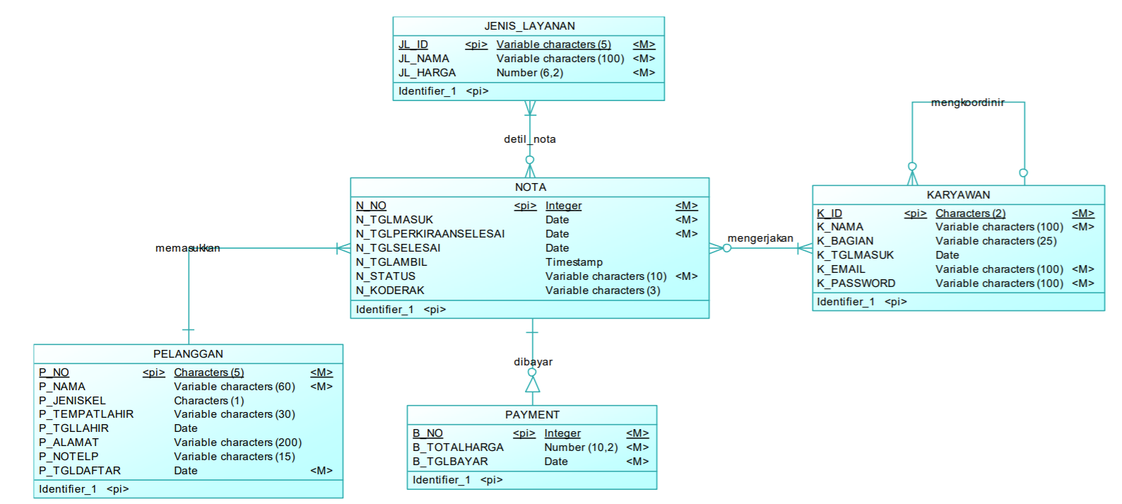

The PDM is as follows:

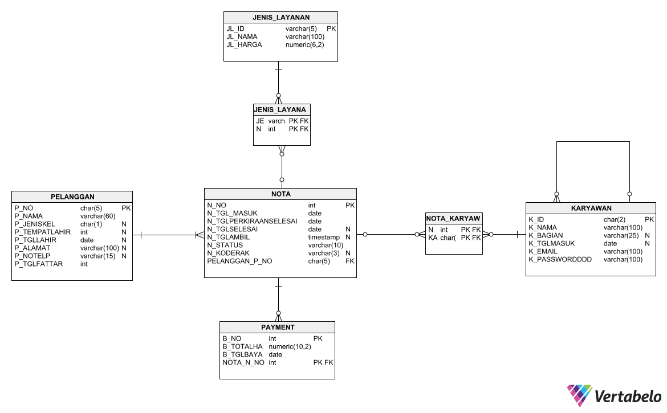

I'll analyze each table in the Physical Data Model (PDM) and provide the normalization status for each one.

Table: jenis_layanan

Attributes: JL_ID, JL_NAMA, JL_HARGA

• 1st Normal Form (1NF):

- All attributes contain atomic values.

- JL_ID, JL_NAMA, and JL_HARGA are atomic attributes.

• 2nd Normal Form (2NF):

- There are no partial dependencies.

- JL_ID is the primary key, and JL_NAMA and JL_HARGA are fully functionally dependent on JL_ID.

• 3rd Normal Form (3NF):

- There are no transitive dependencies.

- JL_ID, JL_NAMA, and JL_HARGA have no indirect dependencies on the primary key.

The table jenis_layanan is in 3rd Normal Form (3NF).

Table: jenis_layanan_nota

Attributes: jenis_layanan_JL_ID, nota_N_NO

• 1st Normal Form (1NF):

- All attributes contain atomic values.

- jenis_layanan_JL_ID and nota_N_NO are atomic attributes.

• 2nd Normal Form (2NF):

- There are no partial dependencies.

- It has a composite primary key (jenis_layanan_JL_ID, nota_N_NO), and all non-key attributes are fully functionally dependent on the entire primary key.

• 3rd Normal Form (3NF):

- There are no transitive dependencies.

- Both attributes have no indirect dependencies on the primary key.

The table jenis_layanan_nota is in 3rd Normal Form (3NF).

Table: karyawan (Employees)

Attributes: K_ID, K_NAMA, K_BAGIAN, K_TGLMASUK, K_EMAIL, K_PASSWORD, K_KOORDINIR

• 1st Normal Form (1NF):

- All attributes contain atomic values.

- K_ID, K_NAMA, K_BAGIAN, K_TGLMASUK, K_EMAIL, K_PASSWORD, K_KOORDINIR are atomic attributes.

• 2nd Normal Form (2NF):

- There are no partial dependencies.

- K_ID is the primary key, and all other attributes are fully functionally dependent on K_ID.

• 3rd Normal Form (3NF):

- There are no transitive dependencies.

- All attributes have no indirect dependencies on the primary key.

The table karyawan is in 3rd Normal Form (3NF).

Table: nota

Attributes: N_NO, N_TGLMASUK, N_TGLPERKIRAANSELESAI, N_TGLSELESAI, N_TGLAMBIL, N_STATUS, N_KODERAK, pelanggan_P_NO

• 1st Normal Form (1NF):

- All attributes contain atomic values.

- N_NO, N_TGLMASUK, N_TGLPERKIRAANSELESAI, N_TGLSELESAI, N_TGLAMBIL, N_STATUS, N_KODERAK, pelanggan_P_NO are atomic attributes.

• 2nd Normal Form (2NF):

- There are no partial dependencies.

- N_NO is the primary key, and all other attributes are fully functionally dependent on N_NO.

• 3rd Normal Form (3NF):

- There are no transitive dependencies.

- All attributes have no indirect dependencies on the primary key.

The table nota is in 3rd Normal Form (3NF).

Table: nota_karyawan

Attributes: nota_N_NO, karyawan_K_ID

• 1st Normal Form (1NF):

- All attributes contain atomic values.

- nota_N_NO and karyawan_K_ID are atomic attributes.

• 2nd Normal Form (2NF):

- There are no partial dependencies.

- The combination of (nota_N_NO, karyawan_K_ID) is the primary key, and both attributes are fully functionally dependent on it.

• 3rd Normal Form (3NF):

- There are no transitive dependencies.

- Both attributes have no indirect dependencies on the primary key.

The table nota_karyawan is in 3rd Normal Form (3NF).

Table: payment

Attributes: B_NO, B_TOTALHARGA, B_TGLBAYAR, nota_N_NO

• 1st Normal Form (1NF):

- All attributes contain atomic values.

- B_NO, B_TOTALHARGA, B_TGLBAYAR, nota_N_NO are atomic attributes.

• 2nd Normal Form (2NF):

- There are no partial dependencies.

- The combination of (B_NO, nota_N_NO) is the primary key, and all attributes are fully functionally dependent on it.

• 3rd Normal Form (3NF):

- There are no transitive dependencies.

- All attributes have no indirect dependencies on the primary key.

The table payment is in 3rd Normal Form (3NF).

Table: pelanggan

Attributes: P_NO, P_NAMA, P_JENISKEL, P_TGLLAHIR, P_ALAMAT, P_NOTELP, P_TGLDAFTAR

• 1st Normal Form (1NF):

- All attributes contain atomic values.

- P_NO, P_NAMA, P_JENISKEL, P_TGLLAHIR, P_ALAMAT, P_NOTELP, P_TGLDAFTAR are atomic attributes.

• 2nd Normal Form (2NF):

- There are no partial dependencies.

- P_NO is the primary key, and all other attributes are fully functionally dependent on P_NO.

• 3rd Normal Form (3NF):

- There are no transitive dependencies.

- All attributes have no indirect dependencies on the primary key.

The table pelanggan is in 3rd Normal Form (3NF).